
Modern Excel Analyst in a Day

Lab 03B
Excel & Power BI service – better together

Overview
The estimated time to complete this lab is 30 minutes.
In this lab, you will complete the following tasks:
- Use Excel to create a pivot table from a Dataset published in the Power BI service
- Add Sparkline Charts

NOTE: This lab has been created based on the sales activities of the fictitious Wi-Fi company called SureWi which has been provided by P3 Adaptive https://p3adaptive.com/. The data is property of P3 Adaptive and has been shared with the purpose of demonstrating Excel and Power BI functionality with industry sample data. Any use of this data must include this attribution to P3 Adaptive.

Exercise 1: Use Excel to create a Pivot Table from a Data Set in the Power BI service
In this exercise, you will use Excel to connect to a published Data Set in the Power BI service.

Task 1: Launch Excel
In this task, you will launch a new blank worksheet to get started.
- Launch Excel.


Note: If you have not already signed in to your O365 account, you may be prompted to sign in – use your work email address and password to sign into your account.
- Create a new blank workbook.
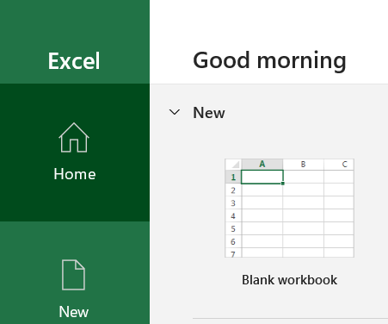

Task 2: Use Insert new Pivot Table from Power BI
In this task, you will create a new Pivot Table workspace connected to a published data set in the Power BI service.
- Select the Insert tab on the Main Excel main ribbon menu.
- Choose PivotTable > From Power BI.
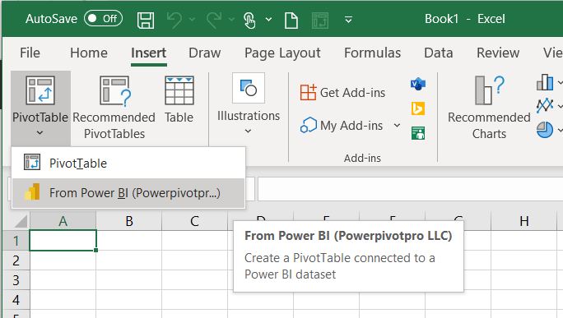
- If you have many published Data Sets, you can use the Search option to type in “Lab”, then select the “MAIAD Lab 03 - Power BI Model” data set from the available data set options.
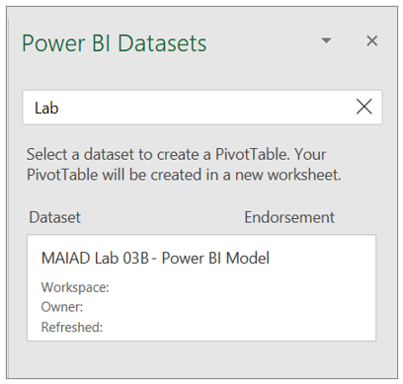

- Notice you have a new Pivot Table workspace and the PivotTable Fields with Measure and Field tables.
Note: Measure tables are identified by the summation icon. This behaviour occurs when Excel connects to a Power BI data set. All Measures that can ONLY go into the Values of the PivotTable Fields will be in located in the summation icon table name. And any of the columns or calculated columns that are used for Filters, Columns, or Rows are located in a table icon of the same name.
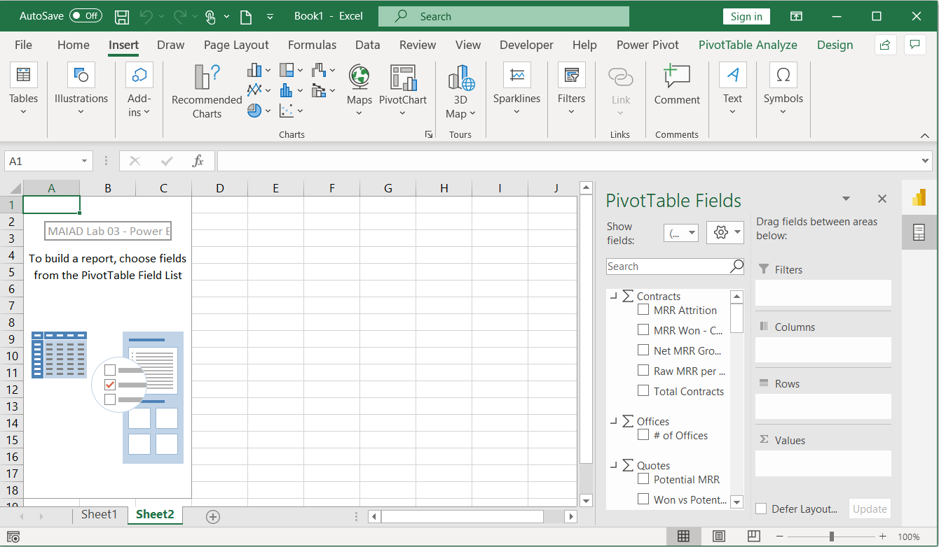
Note: On the right-hand side of the PivotTable Fields window, notice the icons that allow you to toggle the window between Power BI Datasets or PivotTable Fields.
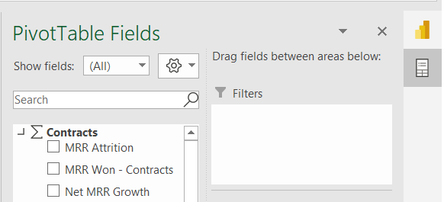

Task 3: Add Measures to the PivotTable Fields Values
In this task, you will populate the PivotTable with Measure fields from the Power BI Dataset connection.
- From the Contracts measure table, drag the [Raw MRR per Office] measure to the Values section in the PivotTable Fields List.
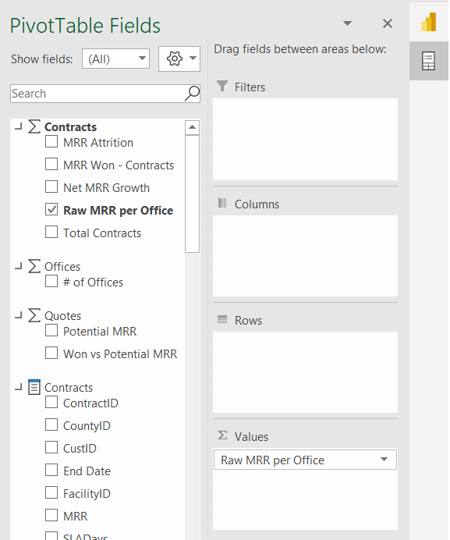

Task 4: Add Fields to the PivotTable Fields Rows
In this task, you will populate the PivotTable with Lookup fields from the Power BI Dataset connection.
- From the Offices field table, drag the [Region] and [District] fields to the Rows section in the PivotTable Fields List.
Note: Lookup field tables are identified by the table with fields icon.

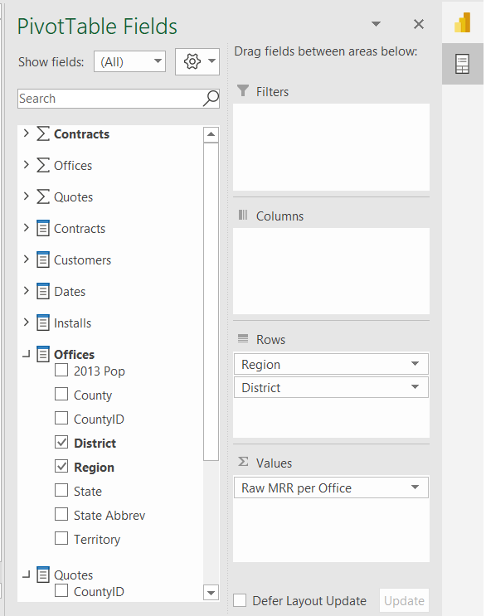
- From the Dates field table, drag the [Year] field to the Columns section in the PivotTable Fields List.
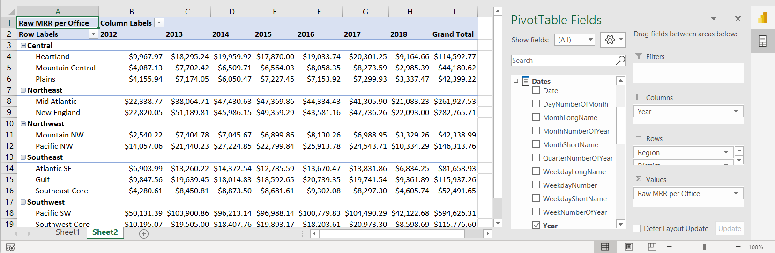

Task 5: Add Slicers
In this task, you will Add Slicers connected to the Pivot Table.
- If the PivotTable Fields list does not display, click on the Pivot Table to make it active and then use a right click and choose Show Field List.
- In the PivotTable Fields, locate the Customers Lookup fields table, right click on the [Company Size] field.
- Select the Add as Slicer option.
Note: The Slicer will just appear in a random location the worksheet – we will reposition the Slicer in the next task.
- You can also add a Slicer from the Main ribbon menu. Click on the Pivot Table to make it active and then click on the PivotTable Analyze tab in the Main ribbon menu.
- Click the Insert Slicer button.
- From the Customers Lookup fields table, click the checkbox next to the [Segment] field.

Task 6: Move & Format Slicers
In this task, you will insert blank Rows and Columns to make space for the Slicers to create a mindful report design for the end users.
- Right-click on Column A and Insert 1 blank column to the left of the Pivot Table.
- Right-click on Column A to resize the Column Width to 1.
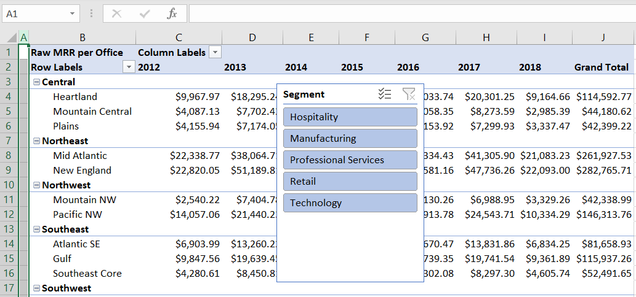
- Right-click in Row 1 and Insert 1 blank row above the Pivot Table.
- Use CTRL+Y to repeat the insert 5 times to create a total of 6 blank rows above the Pivot Table. This will provide space for our Slicers above the Pivot Table.
- Drag the Company Size slicer above the Pivot Table.
- With the Company Size slicer selected, choose the Slicer tab on the Main ribbon menu.
- Change the Slicer Buttons number of Columns to 3.
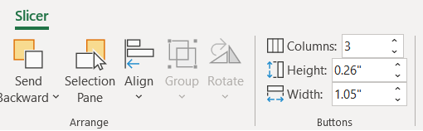
- Change the Slicer Style color to Dark Blue.
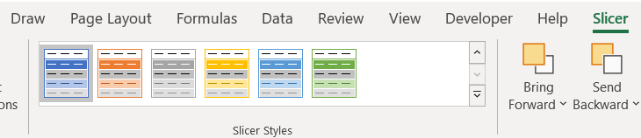
- Drag the Segment slicer above the Pivot Table and to the right of the Company Size slicer.
- With the Segment slicer selected, choose the Slicer tab in the Main ribbon menu.
- Change the Slicer Buttons number of Columns to 5.
- Change the Color to Dark Blue.
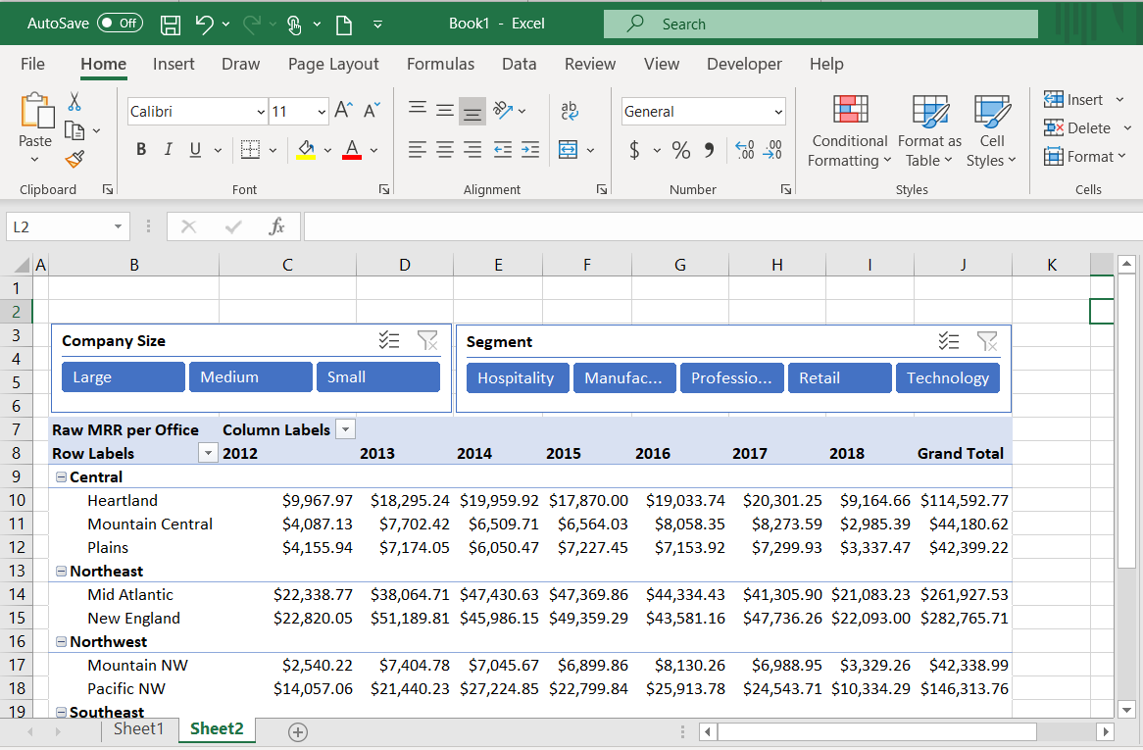

Task 7: Add Report Title & Format Pivot Table
In this task, you will add a title for the Report and apply final formatting to the Pivot Table.
- In cell B2, enter the Report title “MAIAD – Lab 03B – Excel & Power BI service – better together” and use CTRL + B to make the font bold.
- In cell B8, enter the Pivot Table row title “By Region & District”.
- In cell C7, enter the Pivot Table column title “By Year”.
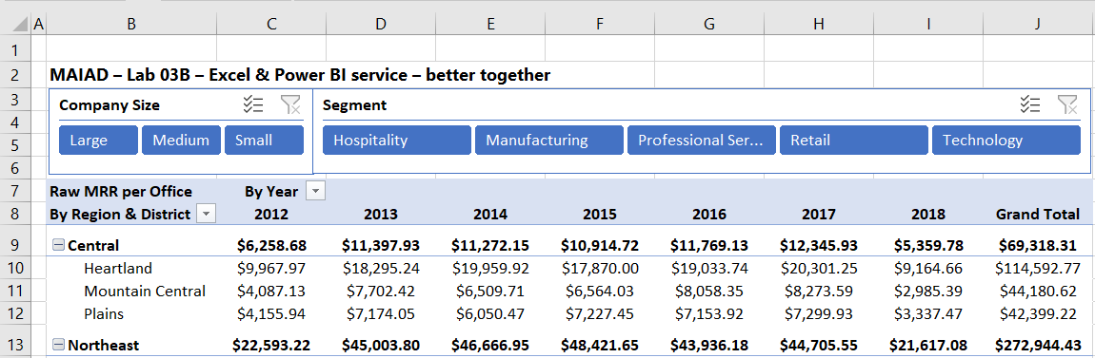
- Click in the Pivot Table to make it active.
- Select Design from the Main ribbon menu > Subtotals button > Subtotals at Top of Group option. This will create Subtotals for each Region in the Pivot Table.
- Highlight Columns C to J and with a right-click, change the Column Width to 12.
- With the Columns C to J still highlighted, select the Center Alignment from the Home tab on the Main ribbon menu.
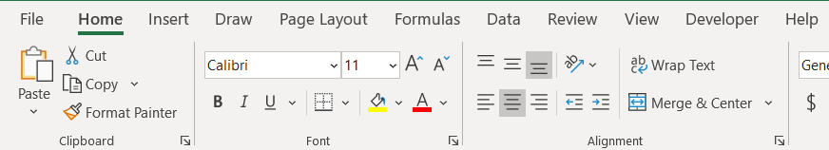
- Expand the Segment Slicer so that each of the values are fully visible to the end user.
- Right-click on the Pivot Table and select PivotTable Options…
- From the Layout & Format tab, de-select the Autofit column widths on update checkbox.
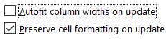

Exercise 2: Add Sparklines
In this exercise, you will create Sparkline charts to display the Year trend next to the Pivot Table.

Task 1: Create Sparkline chart
In this task, you will create a Sparkline chart – combining features in Excel with a Data Model published to the Power BI service.
- Position your cursor in cell K9 then choose Insert from the main ribbon menu and select the Line button.
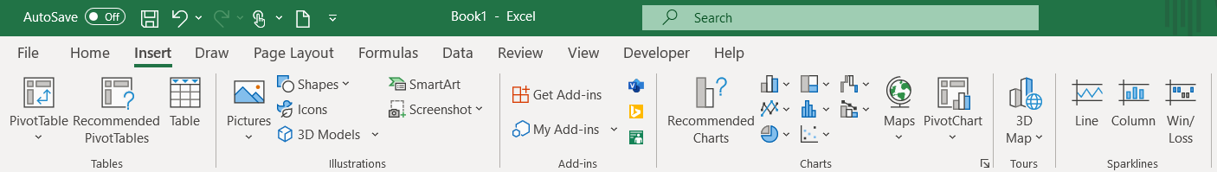
- Enter the Data Range for the Central Region and the Years 2013 to 2017 (D9:H9). Then select the OK button.
- From the Sparkline menu options, select the Sparkline Color drop down and change to Green, Accent 6.
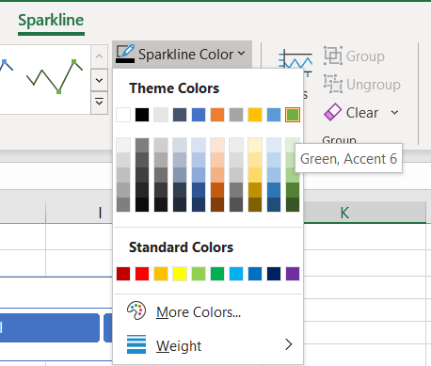

- From the Sparkline menu options, select the Marker Color drop down and add a Green, Accent 6 High Point. Then add a Dark Red Low Point.
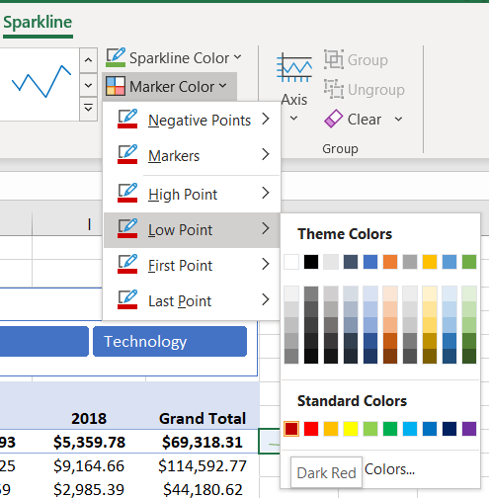
- In Column K, copy/paste the Sparkline for each of the Region rows.
- In cell K8, enter the title “Completed Year Trend”.
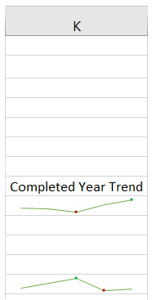

- Hold the CTRL key and highlight each of the Region rows (9, 13, 16, 19, and 23) and then with a right-click, select the Row Height… and change to 20.
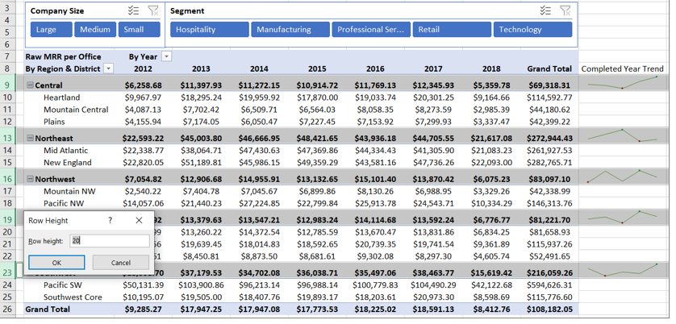

Task 2: Final Formatting
In this task, you will create a final polished report by removing the Excel Headings and Gridlines.
- From the main ribbon menu, select the View tab.
- De-select the Formula Bar, Headings, and Gridlines check boxes.
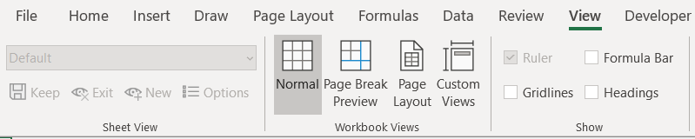

- Select the Pivot Table and use a right-click to display the PivotTable Options and de-select the Autofit column widths on update check box. This will keep the Pivot Table column widths when slicers are selected.
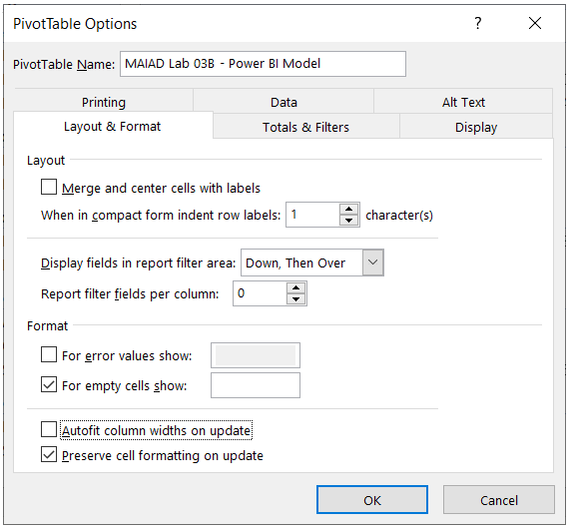

Task 3: Save the Excel file
In this task, you will save the Excel file.
- From the main ribbon menu, select File > Save.
- Navigate to the file <CourseFolder>\Attendee\Lab Materials\Lab 03B\ folder.
- Save the file as “MAIAD Lab 03B – Solution.xlsx”.

Summary
In this lab, you started in the Excel application and connected to a published data set in the Power BI service to create a Pivot Table with Slicers and Sparkline charts – demonstrating how Excel + Power BI is used better together!
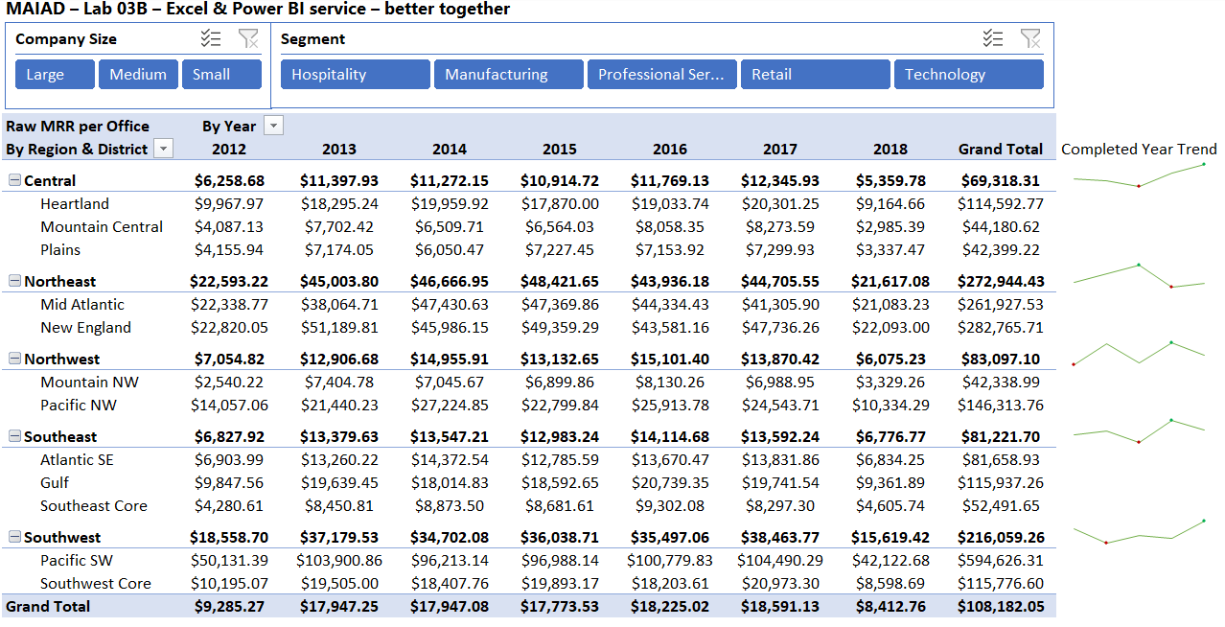

Terms of Use
© 2021 Microsoft. All rights reserved.
By using this hands-on lab, you agree to the following terms:
The technology/functionality described in this hands-on lab is provided by Microsoft Corporation in a “sandbox” testing environment for purposes of obtaining your feedback and to provide you with a learning experience. You may only use the hands-on lab to evaluate such technology features and functionality and provide feedback to Microsoft. You may not use it for any other purpose. Without written permission, you may not modify, copy, distribute, transmit, display, perform, reproduce, publish, license, create derivative works from, transfer, or sell this hands-on lab or any portion thereof.
COPYING OR REPRODUCTION OF THE HANDS-ON LAB (OR ANY PORTION OF IT) TO ANY OTHER SERVER OR LOCATION FOR FURTHER REPRODUCTION OR REDISTRIBUTION WITHOUT WRITTEN PERMISSION IS EXPRESSLY PROHIBITED.
THIS HANDS-ON LAB PROVIDES CERTAIN SOFTWARE TECHNOLOGY/PRODUCT FEATURES AND FUNCTIONALITY, INCLUDING POTENTIAL NEW FEATURES AND CONCEPTS, IN A SIMULATED ENVIRONMENT WITHOUT COMPLEX SET-UP OR INSTALLATION FOR THE PURPOSE DESCRIBED ABOVE. THE TECHNOLOGY/CONCEPTS REPRESENTED IN THIS HANDS-ON LAB MAY NOT REPRESENT FULL FEATURE FUNCTIONALITY AND MAY NOT WORK THE WAY A FINAL VERSION MAY WORK. WE ALSO MAY NOT RELEASE A FINAL VERSION OF SUCH FEATURES OR CONCEPTS. YOUR EXPERIENCE WITH USING SUCH FEATURES AND FUNCITONALITY IN A PHYSICAL ENVIRONMENT MAY ALSO BE DIFFERENT.
FEEDBACK If you give feedback about the technology features, functionality and/or concepts described in this hands-on lab to Microsoft, you give to Microsoft, without charge, the right to use, share and commercialize your feedback in any way and for any purpose. You also give to third parties, without charge, any patent rights needed for their products, technologies and services to use or interface with any specific parts of a Microsoft software or service that includes the feedback. You will not give feedback that is subject to a license that requires Microsoft to license its software or documentation to third parties because we include your feedback in them. These rights survive this agreement.
MICROSOFT CORPORATION HEREBY DISCLAIMS ALL WARRANTIES AND CONDITIONS WITH REGARD TO THE HANDS-ON LAB, INCLUDING ALL WARRANTIES AND CONDITIONS OF MERCHANTABILITY, WHETHER EXPRESS, IMPLIED OR STATUTORY, FITNESS FOR A PARTICULAR PURPOSE, TITLE AND NON-INFRINGEMENT. MICROSOFT DOES NOT MAKE ANY ASSURANCES OR REPRESENTATIONS WITH REGARD TO THE ACCURACY OF THE RESULTS, OUTPUT THAT DERIVES FROM USE OF THE VIRTUAL LAB, OR SUITABILITY OF THE INFORMATION CONTAINED IN THE VIRTUAL LAB FOR ANY PURPOSE.
DISCLAIMER This lab contains only a portion of new features and enhancements in Microsoft Power BI. Some of the features might change in future releases of the product.

